**SETUP YOUR SYSTEM**

Contact: orsolya.vasarhelyi@gmail.com

Python 3.7

**For those who have some version of python installed:**

Make sure you have the following python packages installed:

* Python 3
* IPython and Jupyter notebooks (also called IPython notebook)

Packages:

* requests
* matplotlib
* numpy
* scipy
* pandas
* sklearn
* BeautifulSoup
* networkx

The easiest way to do this is with your python package manager (such as pip). E.g., at the command line: pip install numpy networkx matplotlib pandas scipy sklearn beautifulsoup4 ipython[notebook]  To be sure your system runs all the required packages please move to the 3. TEST YOUR ENVIRONMENT part.

* **For those who do not have python installed yet:**

I recommend to install the Anaconda environment which was created to handle data science projects with python.  **What is Anaconda, and why do we need it?**  Anaconda is an easy­to­install free package manager, environment manager, Python distribution, and collection of over 720 open source packages offering free community. Python similarly to R deals with packages which should be installed and then updated to make sure our codes will run later. Installing and managing packages are relatively easy on OS X and Linux, but on Windows is quite tricky. But Anaconda makes it easier.

1. INSTALL PYTHON WITH ANACONDA Please, go to the official Anaconda site and download Anaconda with **python 3.7.** S imply select the installer appropriate for your platform. Make sure you install the Python 2.7 version. The installer is large, ~200 Mb, so you will need a good connection to download it.

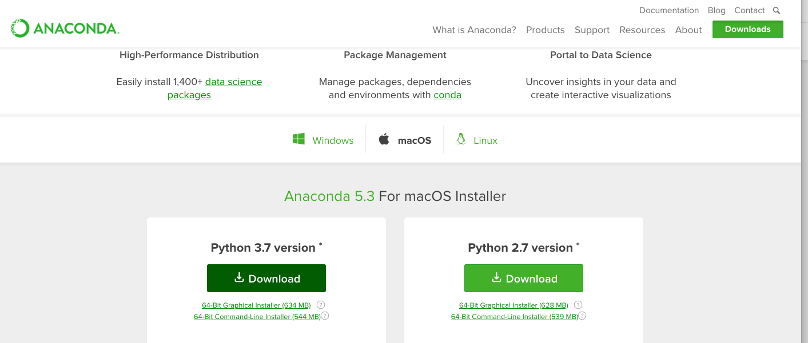

1. LAUNCH JUPYTER NOTEBOOK Open the Anaconda Navigator, and click on Launch Jupyter Notebook.

  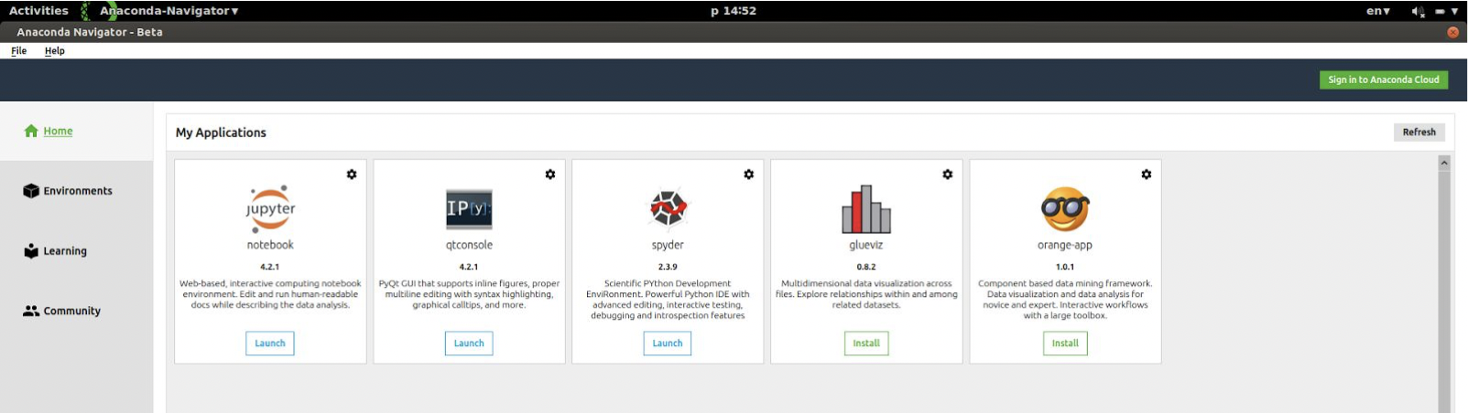

If you are more advanced in using terminal/command line/shell, after navigating into the folder where you would like to save your notebook simply type “jupyter notebook”. This should open a window in your default web browser program. In the upper right hand corner, click New, and then “Python 3” under “Notebooks”. You will get a window that looks similar to:

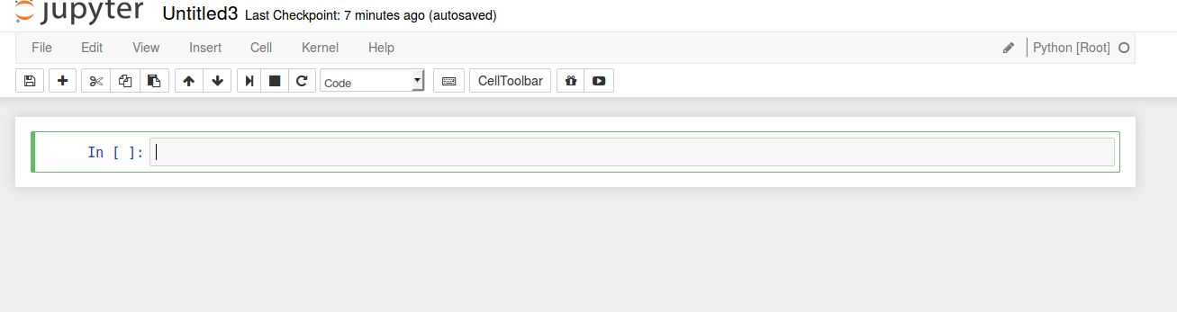

1. TEST YOUR ENVIRONMENT

Please copy the following code into the first line of your notebook, and then press Shift + Enter to execute:

import numpy as np

import pandas as pd

import networkx as nx

from bs4 import BeautifulSoup

import sklearn

import scipy

from scipy import special

import matplotlib.pyplot as plt

%matplotlib inline

It should run without any errors! Be careful of whitespaces, when you copy, it migt cause an error!

Then copy and paste the following code and press shift+enter:

x = np.linspace(0, 10, 100) fig, ax = plt.subplots() for n in range(4):

ax.plot(x, scipy.special.jn(n, x), label=r"$J_%d(x)$" % n) ax.legend

Your notebook should look like this: 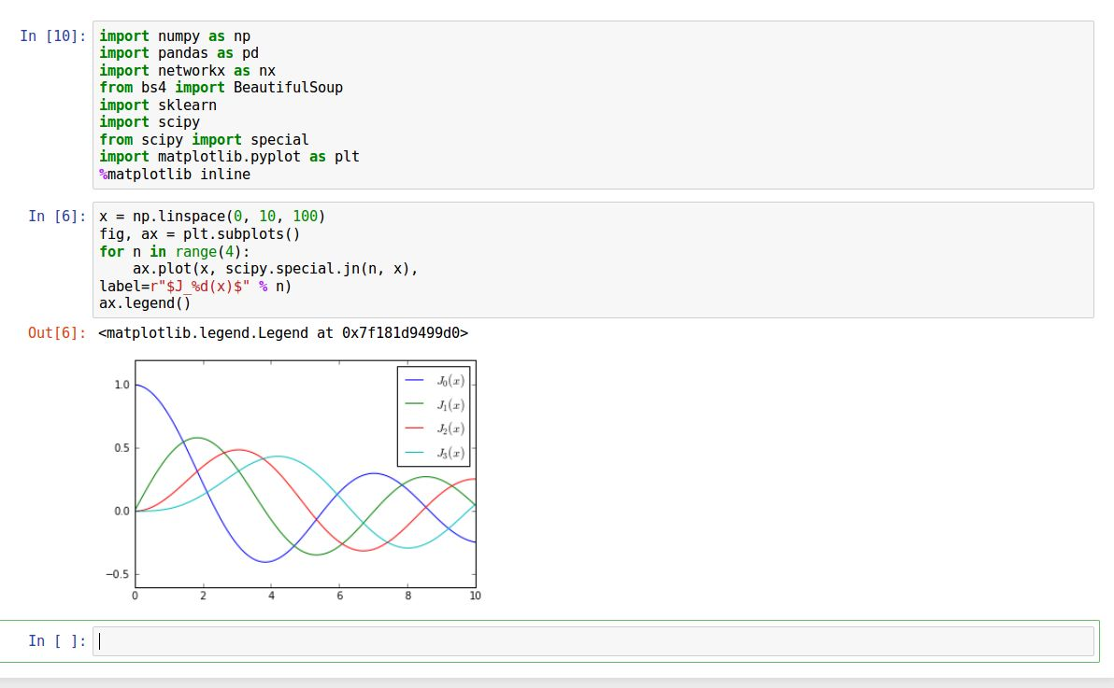

Congratulations! Your system is ready! :)